**MINOR PROJECT**

**CONTROLLING AN LED WITH INPUTS FROM AN ULTRASONIC SENSOR**

**By:**

Urvi Thakur

FOS/BCS/21-24/018

B.Sc(H) Computer Science

**Date:** 5th December, 2023

**Abstract:**

This project introduces an innovative system that utilizes an ultrasonic sensor interfaced with an Arduino microcontroller to dynamically control the illumination of Light Emitting Diodes (LEDs). The integration of ultrasonic technology enables real-time distance measurement, allowing for responsive adjustments in LED brightness based on the user's proximity.

The system's core functionality involves the Arduino continuously receiving distance data from the ultrasonic sensor and modulating the LED intensity accordingly. As an individual approaches or moves away from the sensor, the LED brightness smoothly transitions, creating an interactive and visually engaging experience.

**TABLE OF CONTENTS:**

1. Introduction
2. Project Objective
3. Hardware Requirements
4. Circuit Diagram
5. Step-by-Step Instructions
6. Code
7. Testing and Troubleshooting
8. Conclusion
9. References

**Introduction**

In the realm of interactive electronics, the "Ultrasonic Sensor-Based LED Control System Using Arduino" project stands as a testament to the convergence of sensor technology and microcontroller programming. This innovative system combines the precision of ultrasonic distance measurement with the versatility of Arduino, offering enthusiasts and students a compelling hands-on experience in the world of electronics.

The core concept revolves around the dynamic control of Light Emitting Diodes (LEDs) based on real-time distance data acquired from an ultrasonic sensor. As individuals approach or move away from the sensor, the LED brightness seamlessly adjusts, creating an engaging and interactive visual experience. This project is not merely a technical endeavour; it serves as an educational platform, allowing participants to delve into the intricacies of sensor integration, analog signal processing, and the practical implementation of microcontroller-based systems

**Project Objective**

The primary objective of this project is to provide a comprehensive learning experience for enthusiasts and students, guiding them through the construction of a responsive LED control system that adapts its brightness based on the distance measured by an ultrasonic sensor. Throughout the project, we will gain valuable insights into:

* **Arduino Microcontroller Programming**: Learn the fundamentals of programming Arduino boards to read sensor data and control external devices, enhancing proficiency in C/C++ programming for embedded systems.
* **Ultrasonic Sensor Integration**: Understand the principles of ultrasonic distance measurement, including sensor calibration, data acquisition, and signal processing. Explore how to interface the ultrasonic sensor seamlessly with the Arduino platform

**Hardware Requirements**

* Arduino Uno Board
* Ultrasonic Sensor
* LED
* Jumper Cables
* USB Cable for Arduino

**Circuit Diagram**

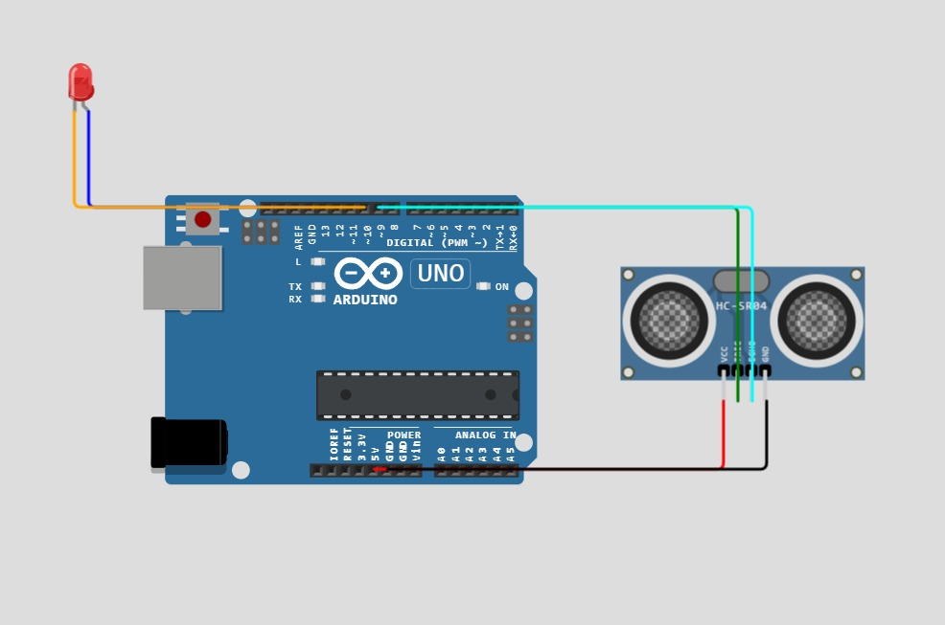

**Step-By-Step Instructions**

1. **Connect the Ultrasonic Sensor to Arduino**: Establish the wiring connections between the ultrasonic sensor and the Arduino using jumper wires.
2. **Connect LEDs and Resistors**: Set up the LEDs with appropriate resistors on the breadboard.
3. **Write Arduino Code**: Develop the Arduino code to read ultrasonic sensor data and modulate LED brightness based on distance.
4. **Upload Code to Arduino**: Use the Arduino IDE to upload the code to the Arduino board.
5. **Power Up the System**: Connect the power supply to the Arduino board and observe the LED responses.

**Code**

// Arduino program to control an LED using an Ultrasonic Sensor

const int trigPin = 9; // Trig pin of the ultrasonic sensor

const int echoPin = 10; // Echo pin of the ultrasonic sensor

const int ledPin = 6; // Pin connected to the LED

const int distanceThreshold = 20; // Distance threshold in centimeters for turning on the LED

void setup() {

Serial.begin(9600);

pinMode(trigPin, OUTPUT);

pinMode(echoPin, INPUT);

pinMode(ledPin, OUTPUT);

}

void loop() {

// Trigger the ultrasonic sensor to send a pulse

digitalWrite(trigPin, LOW);

delayMicroseconds(2);

digitalWrite(trigPin, HIGH);

delayMicroseconds(10);

digitalWrite(trigPin, LOW);

// Measure the time taken for the pulse to return

long duration = pulseIn(echoPin, HIGH);

// Convert the time to distance in centimeters

int distance = duration * 0.0343 / 2;

Serial.print("Distance: ");

Serial.print(distance);

Serial.println(" cm");

// Check if an object is within the specified range

if (distance < distanceThreshold) {

// Turn on the LED

digitalWrite(ledPin, HIGH);

} else {

// Turn off the LED

digitalWrite(ledPin, LOW);

}

delay(500); // Add a small delay for stability

}

**Explanation**

* **Constants Declaration:**
  + **trigPin (9)**: Defines the pin connected to the trigger (Trig) of the ultrasonic sensor.
  + **echoPin (10)**: Defines the pin connected to the echo (Echo) of the ultrasonic sensor.
  + **ledPin (6)**: Defines the pin connected to the LED.
  + **distanceThreshold (20)**: Specifies the distance threshold in centimeters for turning on the LED.
* **Setup Function:**
  + Initializes serial communication for debugging purposes.
  + Sets the trigPin as an OUTPUT to send pulses to the ultrasonic sensor.
  + Sets the echoPin as an INPUT to receive the return pulse from the ultrasonic sensor.
  + Sets the ledPin as an OUTPUT to control the LED.
* **Loop Function:**
  + Triggers the ultrasonic sensor to send a pulse by briefly setting the trigPin to HIGH and then LOW.
  + Measures the time it takes for the pulse to return using **pulseIn** and calculates the distance in centimeters.
  + Prints the measured distance to the serial monitor for debugging.
  + Checks if the measured distance is less than the specified threshold (**distanceThreshold**).
    - If true, turns on the LED by setting the ledPin to HIGH.
    - If false, turns off the LED by setting the ledPin to LOW.
  + Adds a small delay (500 milliseconds) for stability and to avoid rapid changes in LED state.

**Testing**

1. **Power Up the System:**
   * Connect the Arduino board to a power supply.
   * Observe the LED and ensure it is initially off.
2. **Move an Object Toward the Ultrasonic Sensor:**
   * Gradually approach the ultrasonic sensor with an object.
   * Verify that the LED turns on when the object is within the specified distance threshold (**distanceThreshold**).
3. **Move the Object Away:**
   * Gradually move the object away from the ultrasonic sensor.
   * Confirm that the LED turns off when the object is beyond the specified distance.

**Troubleshooting**

If you encounter issues during testing, consider the following troubleshooting steps:

1. **Check Wiring Connections:**
   * Ensure that all connections between the ultrasonic sensor, LED, and Arduino are secure and correct.
   * Recheck the wiring against the circuit diagram.
2. **Verify Power Supply:**
   * Confirm that the Arduino board is receiving power from a stable power supply.
   * Check that the LED has the correct voltage and current requirements.
3. **Inspect Serial Monitor Output:**
   * Open the Arduino IDE and navigate to "Tools" > "Serial Monitor" to view distance measurements.
   * Verify that the distance readings are reasonable and consistent.
4. **Adjust Distance Threshold:**
   * Modify the **distanceThreshold** value in the code to better suit your testing environment.
5. **Sensor Calibration:**
   * Ensure the ultrasonic sensor is calibrated and functioning correctly.
   * Adjust sensor orientation and placement to optimize distance measurement.
6. **Check for Interference:**
   * Eliminate potential interference sources, such as reflective surfaces or acoustic obstacles in the sensor's field.
7. **Inspect LED and Resistor:**
   * Verify that the LED and resistor are connected properly and are within their specified operating parameters.

**Conclusion**

The Ultrasonic Sensor-Based LED Control System Using Arduino represents a successful convergence of sensor technology and microcontroller programming, providing an engaging and educational exploration into the world of interactive electronics. Through the development of this project, several key insights and accomplishments have been realized:

* **Hands-On Learning:** We have gained hands-on experience in assembling electronic components, interfacing an ultrasonic sensor with an Arduino microcontroller, and programming the system for dynamic LED control.
* **Arduino Proficiency:** The project has served as a valuable tool for enhancing proficiency in Arduino programming, offering a practical application for C/C++ programming skills in the context of embedded systems.
* **Sensor Integration:** Understanding the principles of ultrasonic distance measurement has enabled participants to seamlessly integrate sensor technology, fostering a deeper appreciation for real-world applications in distance sensing
* **Interactive Electronics:** Beyond the technical aspects, the project has highlighted the interactive nature of electronics, as the LED responds dynamically to the proximity of objects, creating an immersive and visually engaging experience

**References**

1. <https://subsequent-friday-236.notion.site/Minor-Project-Ideas-B-Sc-2023-21-24-Batch-81c0db942ae74406a07ea6037be224be>

2.<https://www.instructables.com/Motion-activated-light-with-Arduino-and-HC-SR04-se/>